**NETWORK LAYER**

**Switching Techniques**

* In large networks, the sender to receiver path **may** **not be direct**.
* **Switching technique:** A technique for deciding **best route** for data transmission.
* It enables **one-to-one** communication among systems.

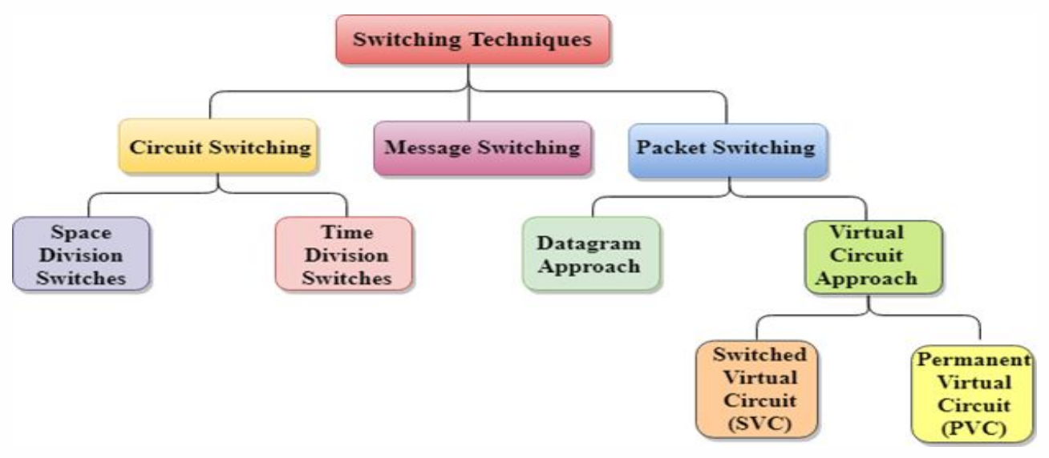

**Circuit Switching**

* This technique is used for creating a **dedicated path** between sender & receiver.
* And this path exists until the connection between them is **terminated**.
* **Telephones** work on the same principle.

Advantages:-

* Reliable
* Fixed bandwidth

Disadvantages:-

* It takes a **long time** to be established.
* Expensive

**Message Switching**

* In this switching technique, whole data is transmitted **at once**.
* But they are passed from **connected nodes** to reach the destination.
* Data are **stored & forwarded** from those nodes.
* Also known as **store and forward network**.

Advantages:-

* Efficient
* Low bandwidth requirement.
* **Less chances of traffic congestion**; as data are **not** continuously transmitted, but stored in intermediate nodes.
* Priority based network.

Disadvantages:-

* **Insufficient storage** for storing multiple data.
* **Transfer delay** due to many storing sessions.

**Packet Switching**

* In this method, **data are split** into small pieces & then transmitted.
* Different pieces may take **separate route** to destination.
* After reaching the destination, they are **arranged in the required order**; using a **unique identity** number that they were given.
* If any piece of data is **missing or corrupted**, the sender resends the data.
* Else it receives an **acknowledgement**.

Advantages:-

* Cost effective
* Reliable
* No traffic congestion

Disadvantages:-

* High delay
* Low quality
* Expensive
* High overhead

**Logical Addressing**

* **IPv4 Address:** 32-bit IP address.
* Two devices connected to internet **can’t** have **same address** at the same time.

**Ex: Binary: 01110101 10010101 00011101 00000010**

**Decimal: 117.149.29.2**

**Classful Addressing**

IP address sub-classes:-

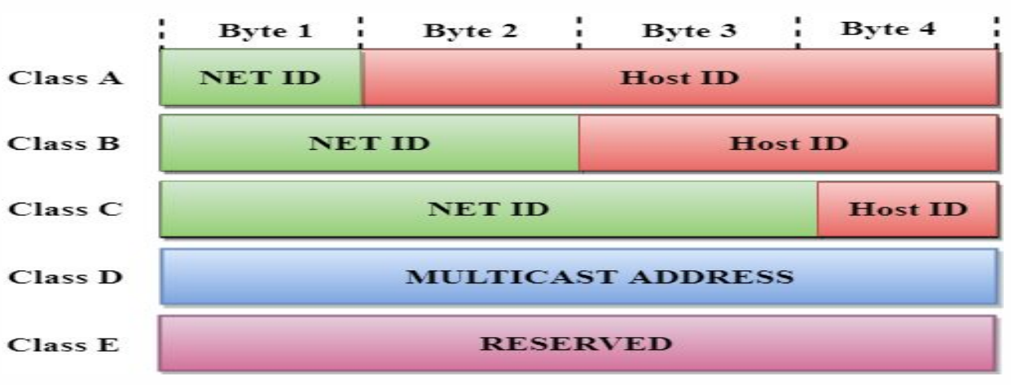

* ***\*Notice that its byte above, not bit\****
* **Network ID:** Represents number of **networks**.
* **Host ID:** Represents number of **hosts**.

**Classes**

Class A:-

* Used in networks with **large** number of hosts
* **First** **bit** is always **0**.

Class B:-

* Used networks with **small to large** number of hosts.
* **First bit** is always **0**.
* **Second bit** is always **1**.

Class C:-

* Used in networks with **small** number of hosts.
* **First bit** is always **1**.
* **Second bit** is always **1**.
* **Third bit** is always **0**.

Class D:-

* Reserved for **multicasting addresses**.
* **Multicasting addresses:** A logical address for a **group of hosts**.
* It **doesn’t** support subnetting.
* **Subnet:** Part of the **network path**.
* **First bit** is always **1**.
* **Second bit** is always **1**.
* **Third bit** is always **1**.
* **Fourth bit** is always **0**.

Class E:-

* Used for **research purposes** by developers, consumers **can’t access** it.
* It **doesn’t** support **subnetting**.
* **First bit** is always **1**.
* **Second bit** is always **1**.
* **Third bit** is always **1**.
* **Fourth bit** is always **1**.

**Why Use IPv6?**

* It supports **subnetting**.
* It supports **supernetting**.
* **Supernetting:** Collection of **multiple class Cs** to create even **larger** **network**.
* Works with less internet resources, tackling resource **depletion issues**.

**Classless Addressing**

* Addresses are kept in **blocks** but **without** any **classes**.
* When an entity has to **connect** to the internet, a **block** is given to it as per its **size**.
* Despite solutions like **classful** & **classless** addressing, **DHCP** **address depletion** still remains a big issue.
* **DHCP:** **Dynamic host configuration protocol**, which automatically assigns IP address to users connected to the internet. **Without** manual configuration.

**IPv6**

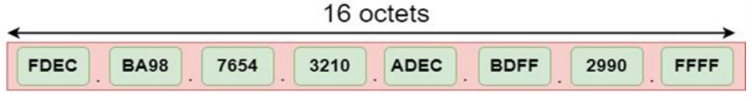

* It is **128-bits long**.
* **Hexadecimal colon notation:** **128-bit** is divided into eight parts in this notation.
* Means each part represents **16-bits** i.e. **2 bytes**.
* And **2-byte** data can be represented with **four hexadecimal digits**.
* Thus, there are total of **32 hexadecimal digits**.
* Each 4-digited hexadecimal number is separated by **colon** **(:)**.
* **Address space:** Number of addresses possible (like **IPv6** can take **2128 addresses**).
* **Unicast address:** **Unique address** used to **send data** to a **particular computer**.
* ***\*MAC address just identifies a computer uniquely\****
* **Multicast address:** An address used to deliver data to **each host in a group** connected to common network.
* ***\*Note: Host & clients are different\****
* **Reserved addresses:** These addresses are used by **various protocols** for ensuring proper working of internet.
* They start with **eight zeroes** (**00000000**).

**IPv4 Header**

* **IP** receives data from **4th layer** of OSI model.
* Then **divides** the data into various packets.
* Then it **encapsulates** those data & adds its own **header** information on it.
* This **header** contains various **routing** & **addressing** information.

Short comings:-

* **Doesn’t** solve the **address depletion** issue.
* High transmission delay, making it unsuitable for **real-time** audio & video streaming.
* **Doesn’t** provide **security facilities** like encryption & authentication.

**IPv6 Header**

* Each packet consists of **base header** & **payload**.
* **Base header** contains the **same header information** & occupies **40 bytes**.
* **Payload** contains **extension for header** & **data**.
* And it can occupy **upto 65,535 bytes** of information.

**Transition From IPv4 to IPv6**

Three transition strategies:-

* Dual stack
* Tunneling
* NAT protocol translation

Dual stack:-

* Router uses both **IPv4** & **IPv6** configuration.
* And both point & **work to their respective network** clouds/spaces.

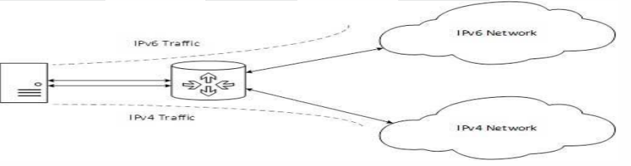

Tunneling:-

* A **better** solution.
* User’s data can pass through **non-supported IP address** & reach its destination.

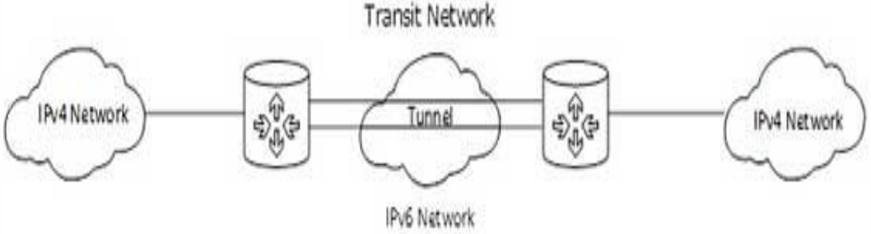

NAT protocol translation:-

* **NAT-PT** means ***network address translation – protocol translation***.
* In this, the **NAT enabled device** routes the data to the network cloud as per the **IP version** it used.

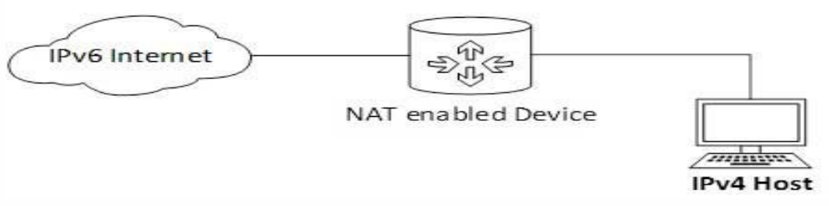

**Address Resolution Protocol (ARP)**

* When communicating, a host requires **MAC address** of the destination device.
* And this device must be **connected** to the same network channel.
* **MAC address** is also known as ***layer-2 address***.
* If **NIC** is **changed** due to some fault, it results in **change of MAC address**.
* So, in order to communicate on internet again; the IP address needs to be refreshed.

Broadcasting conversation using ARP:-

* **Address routing protocol (ARP):** Allows packet to contain host’s IP address.
* To **initiate** a broadcast message, the device checks who has **its IP address** in the same network, requesting for conversation using ***ARP***.
* Then the devices having it **reply back** with **ARP**.
* Then sender **broadcasts** the message to their **MAC addresses** using **ARP**.
* **ARP** is transmitted **along with** data package when communicating.
* Then for the rest of the conversation, devices use their **own IP address** to send & **receiver’s MAC address** to receive the data.

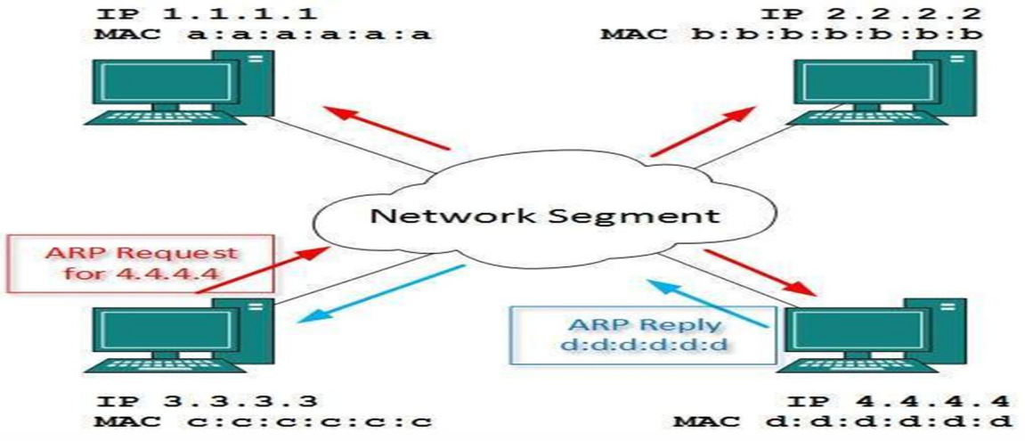

* These **MAC to IP mappings** of both sender & receiver is saved as **cache**.
* And this is only when they communicate for the **first time**.
* Rest of the time, they **don’t** require each other’s IP or MAC addresses.
* These conversations can be done using **ARP cache**, produced **after first conversation**.

**Dynamic Host Configuration Protocol (DHCP)**

***\*Also discussed earlier\****

* Can be used in both **local** & **enterprise servers**, irrespective of network size.
* **DHCP** is a **default protocol** used by **most** networking devices; including routers.
* **DHCP** is also known as ***RFC*** (***request for comment***).

**Bootstrap Protocol (BOOTP)**

* Used by a **client** for obtaining **IP address** of a server.
* Earlier it was made to **save** a computer’s **network connections** before booting up.
* One **BOOTP** **server** can serve as host on **multiple subnets**.

**Delivery**

* **Direct delivery:** The network shared by the sending & receiving hosts is **same**.
* **Indirect delivery:** The packet goes **router to router** until it reaches the **destination host**.

**Forwarding**

* **Forwarding:** **Placing** a packet on the **route** leading to its destination.
* This is done by **checking** various **destinations** on a table.
* But this method is **impossible these days** due to **large** number of entities, making it difficult to make each entry on the table.

**Routing**

* **Routing:** **Selection of path** for transferring packets from sender to destination.
* Routing is done by **router**.
* Router decides path as per the information on **packet’s header** & **forwarding table**.

Types of routing:-

* Static routing
* Default routing
* Dynamic routing

Routing tables:-

* **Static routing table:** Contains **manual** information entries.
* **Dynamic routing table:** Automatically updated when a change occurs in the internet.

Intra and inter domain routing:-

* **Autonomous system (AS): Group** of networks & routers under **single authority**.
* **Intra-domain routing:** Routing **inside** the autonomous system.
* **Inter-domain routing:** Routing **between** **many** autonomous systems.

**Types of Routing Protocols**

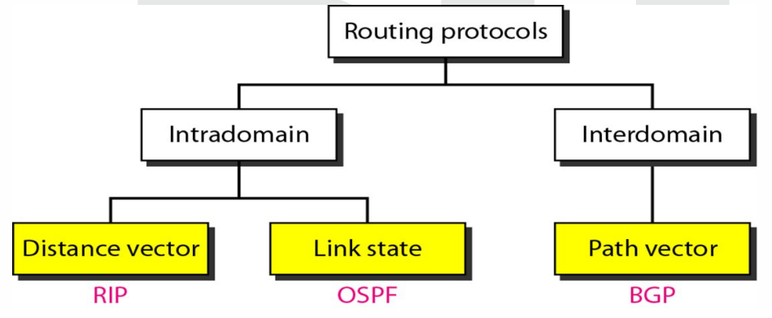

**Distance Vector Routing (DVR)**

* In this type of routing, the **cheapest route** between two nodes; is the **shortest route** too.
* Each node maintains a ***routing table*** telling shortest route to other nodes from it.
* This table has a column called **cost**, which is less is nearby nodes.
* So, data travels through the **shortest route** from node to node, **saving time**.
* This **continuous short path traversal** is known as ***next-hop routing***.

Issues with DVR:-

* Sometimes when travelling from node to node, the **packet is lost**.
* Then the distance between the **current node** & **next node** becomes **infinity** on table.

***\*Colour white means current node, grey is distance & yellow is next node\****

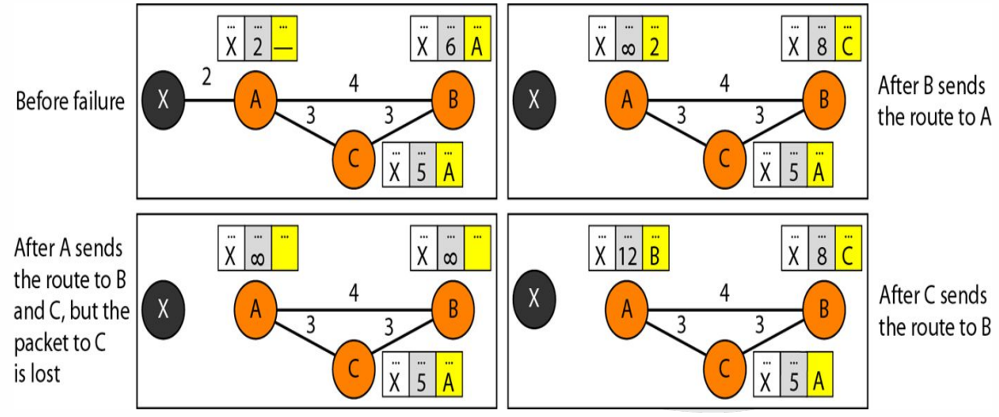

**Link State Routing**

* In this, the nodes contain all information about the **topology/structure** in their table.
* This information includes **nearby connections**, **cost**, **type of connection** etc.
* And thus, it uses ***Dijkstra’s algorithm*** to build a **separate routing table** for the nodes.
* However, the calculations **might be different** for each node; because each node calculate on the basis of their individual perspective on **links** to other nodes.

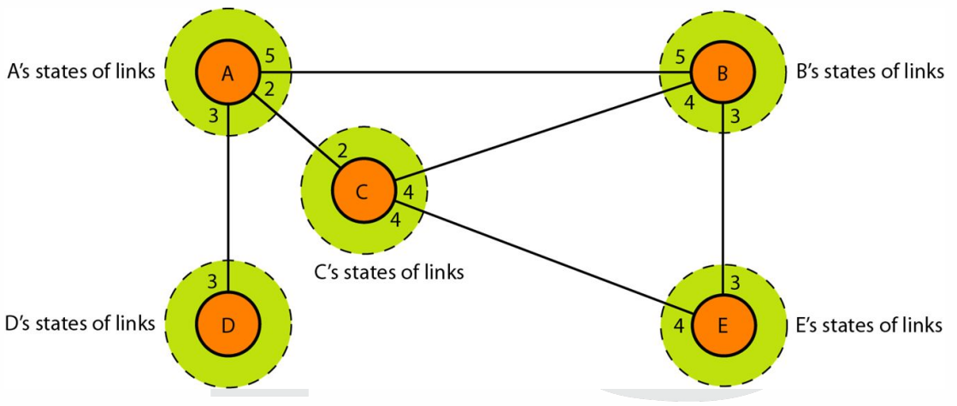

**Path Vector Routing**

* ***Distance vector routing*** & ***link state routing*** are only used for **intradomain** **communication**.
* This is because interdomain requires **high scalability**, which is **absent** in both of them.
* Both of these routing methods **can’t be tracked** when travelling **large** distances.
* ***Distance vector routing*** becomes **unstable** with **multiple hops**.
* ***Link state routing*** requires huge amount of information for calculating routing table.
* Thus, they create **high overhead**.
* And that’s when comes another routing protocol called ***path vector routing***.
* **BGP:** A **path vector protocol** used for **inter-domain communication**.
* The **nodes** receive the **distance vector** instead of the **router**.
* This is done so that node can do **routing calculations**.